**Create a website using React**

For creating a website, we require the following tools

* Install visual studio
* Install npm
* Install react

**How to install Visual Studio**

Step1: Download Visual Studio

Step2: Double click the downloaded file

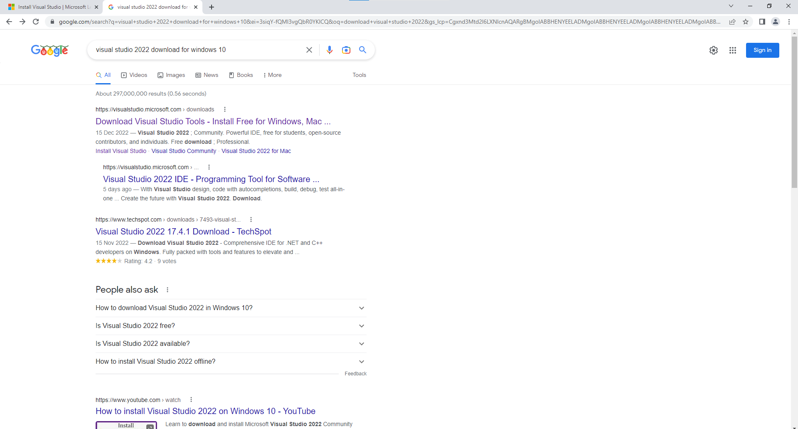

Click the first link

Step3: Click **free download** from **Community**.

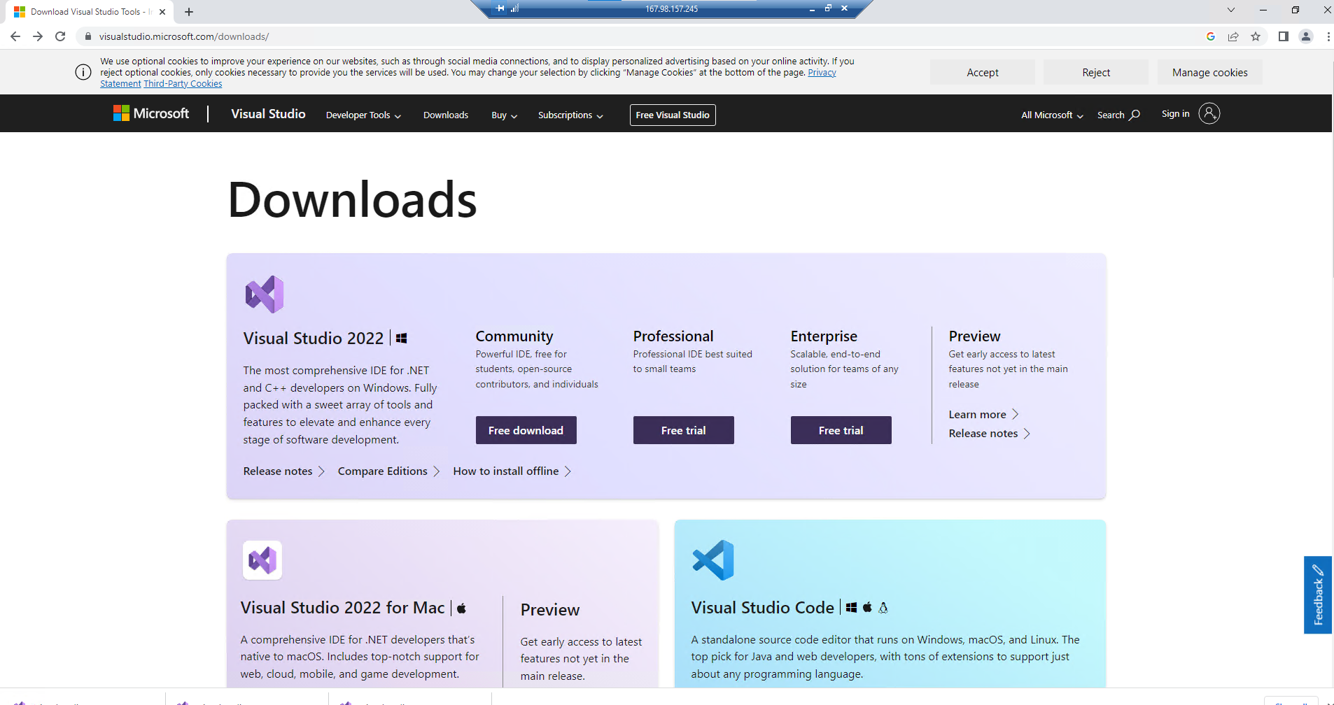

Step4: Double click the downloaded file from downloads.

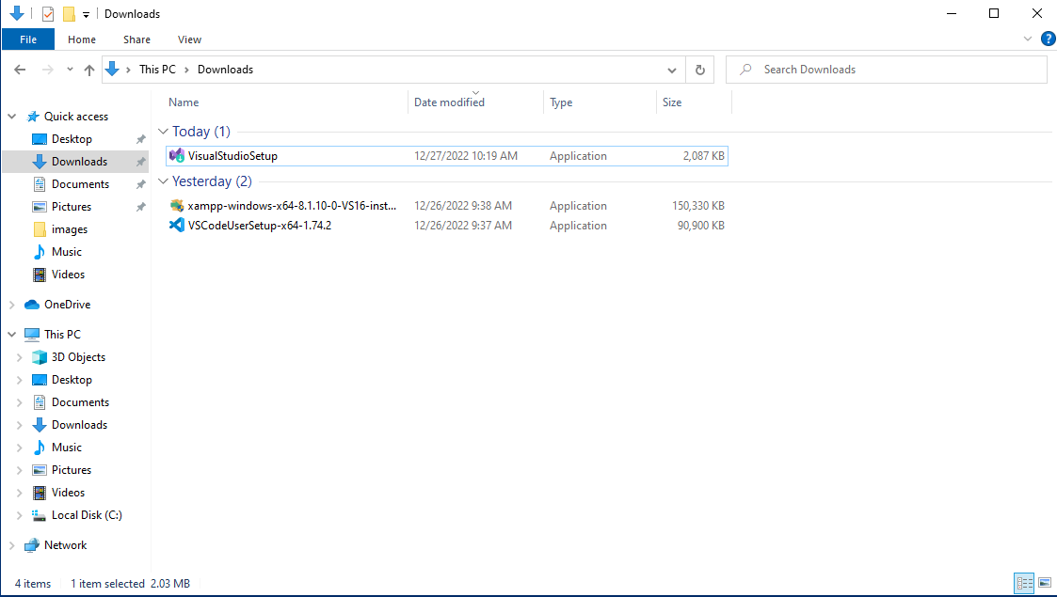

Step5: Then click ’yes’

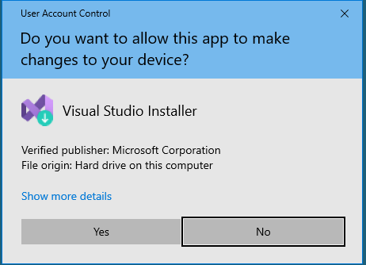

Step6: Click continue.

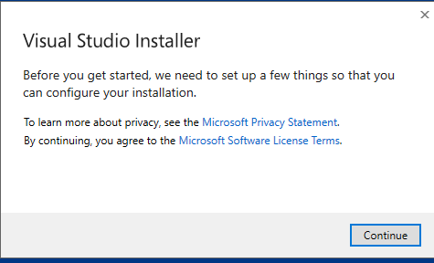

Step7: Click the install button

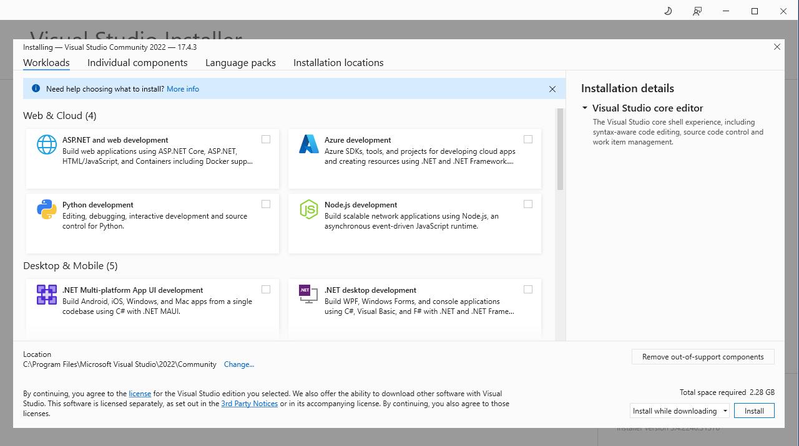

Step8: Click the continue button

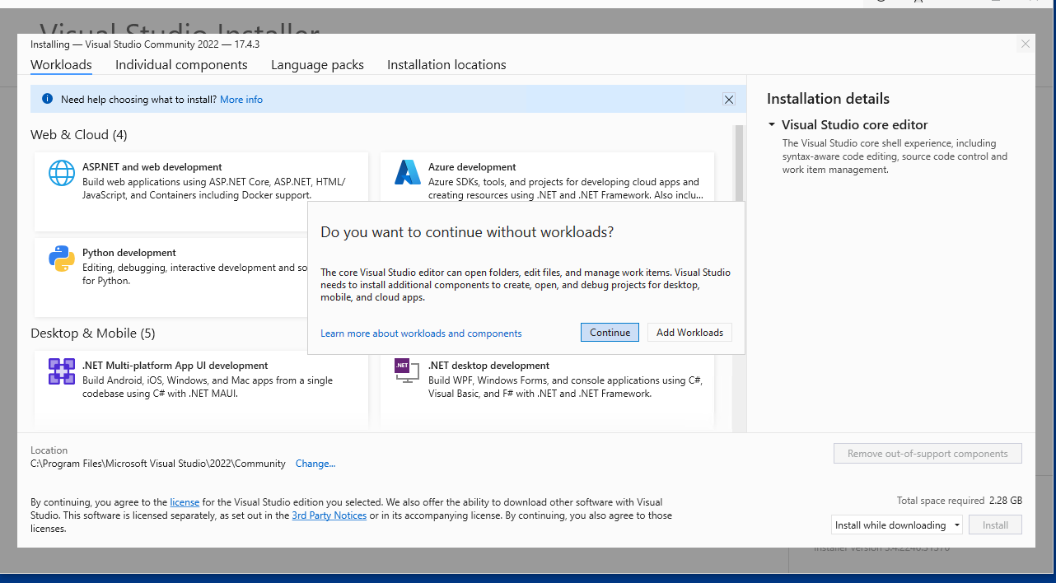

Step9: Then click **start visual studio**

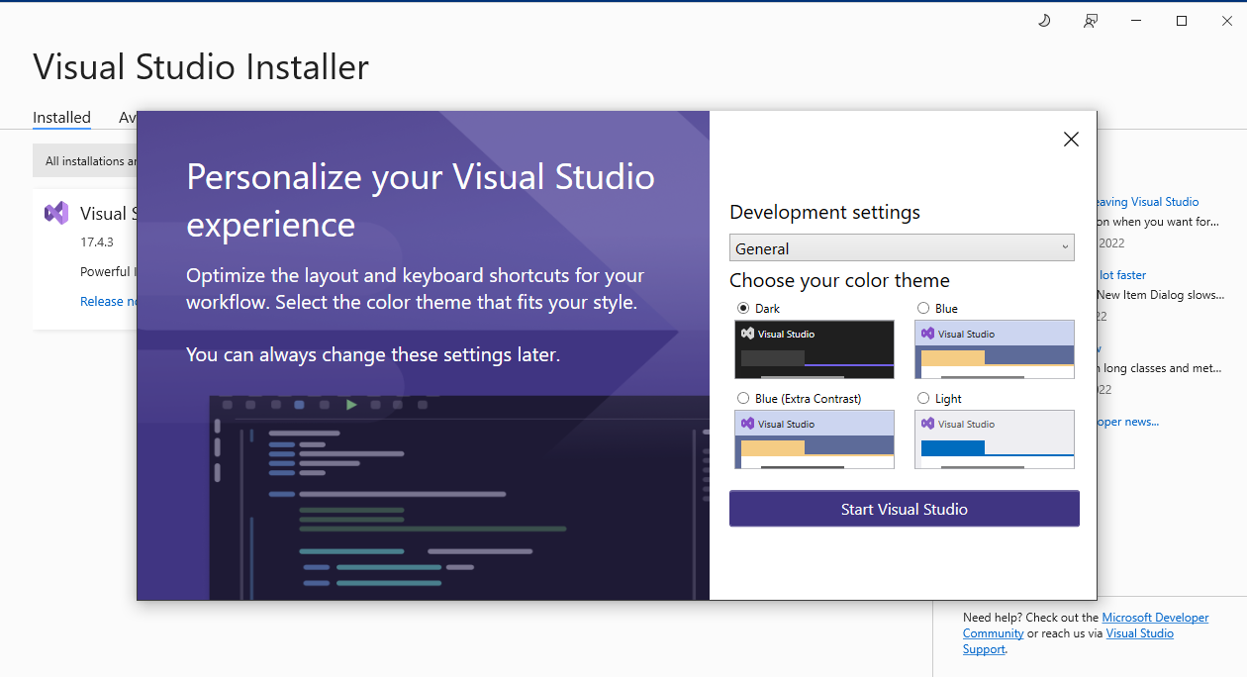

Now visual studio will appear in your screen.

**Steps for installing npm**

Before installing npm we require **node.js**

1. First go to this link <https://nodejs.org/en/>
2. Click the 18.12.1 version for node js

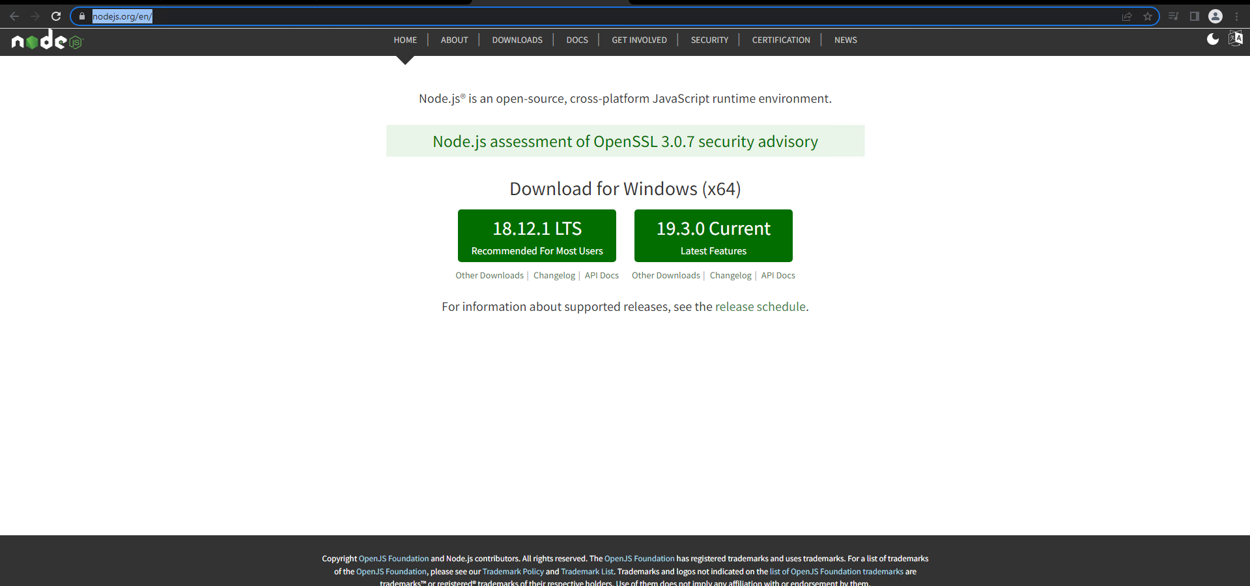

1. Double click the downloaded file and click the next button

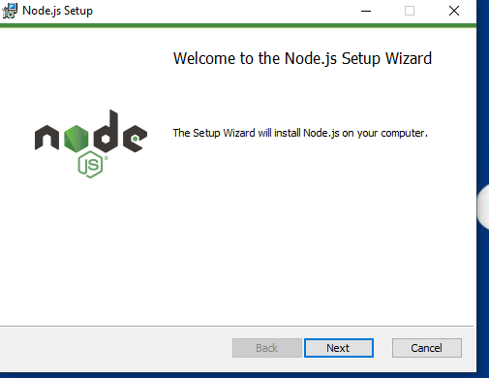

1. Tick the check box and click next button

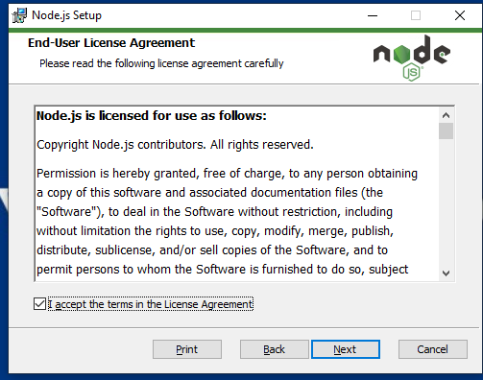

1. Click the next button

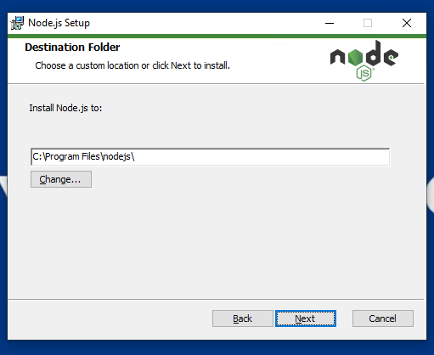

1. Select the npm package manager and Click the next button

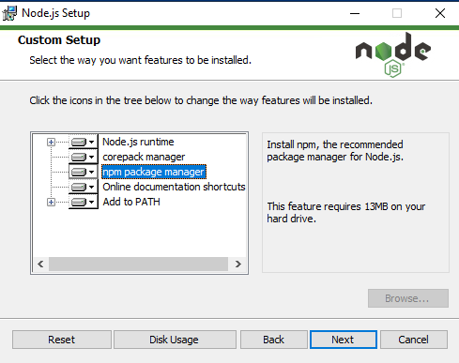

1. Tick the checkbox and click the next button

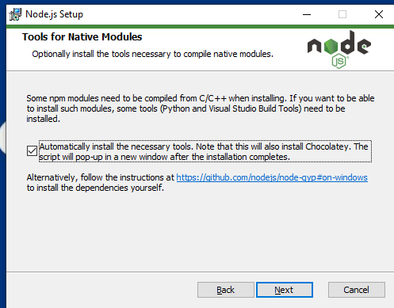

1. Click the install button

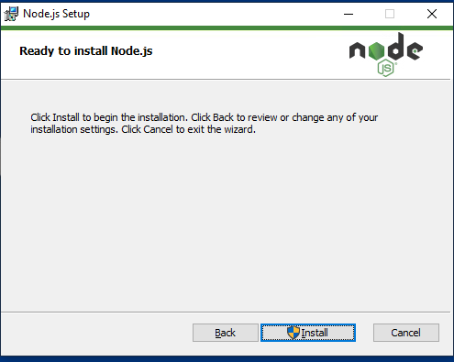

1. Click the finish button

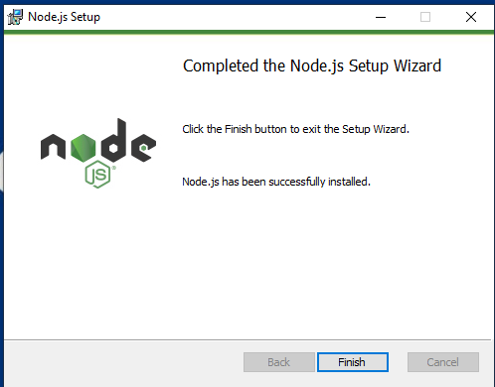

Node js installed in our system. It will automatically install **npm** in our system.

**How to install react**

* The following command is used to create a react app in our system.s

**npx create-react-app my-app**

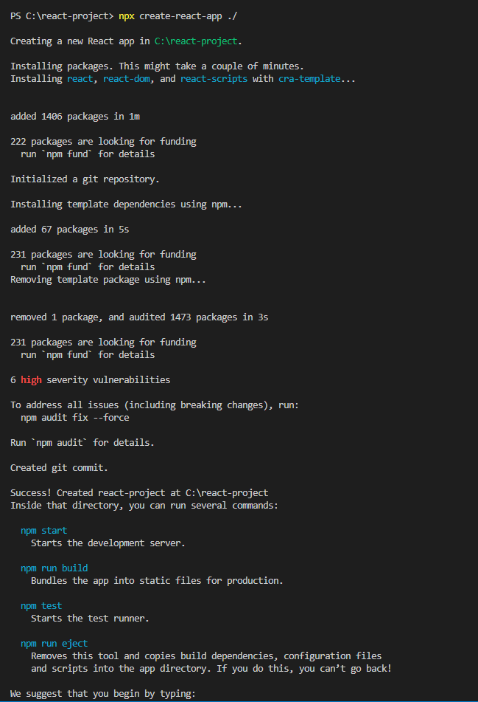

If you’re **learning React,** we recommend **create** **react app** It is the most popular way to try out React and build a new single-page, client-side application. It’s made for React but isn’t opinionated about routing or data fetching.

Then open our folder in visual studio. We can see the following folder inside our project.

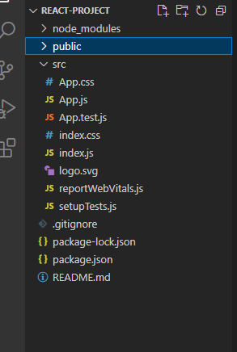

* The following command is used to run our app.

**npm start**

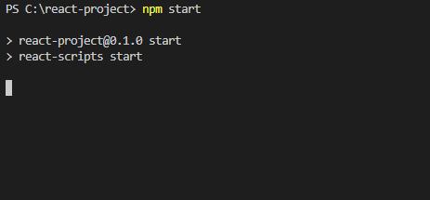

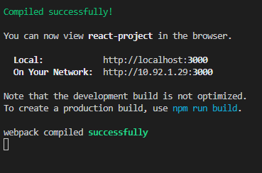

It will automatically open web browser to run our project on localhost:3000

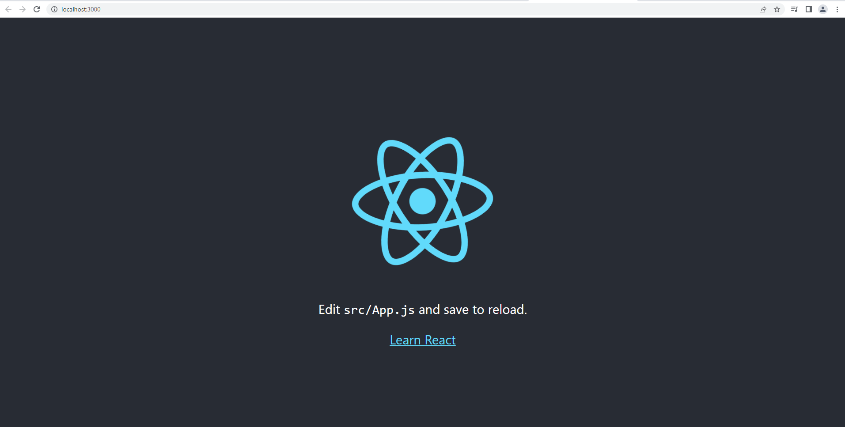

Package.json contain all packages related react.

 "react": "^18.2.0",

    "react-dom": "^18.2.0",

    "react-scripts": "5.0.1",

In public folder we can see a single html file index.html

**React** library is responsible for creating views and **ReactDOM** library is responsible to actually render UI in the browser.

The **react-scripts** package is a set of scripts from the create-react-app starter pack which helps you kick off projects without configuring.

When we open the public folder we can see the following files.

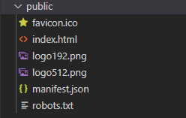

The **public folder**contains static files such as **index. html**, JavaScript library files, images, and other assets, etc. which you don't want to be processed by web pack. Files in this folder are copied and pasted as they are directly into the build folder.

**Index.html** contain the following line.

<div id="root"></div>

public/index. html is **the main HTML file of our app that includes your React code and provides a context for React to render to**. Let's take a look at the file: Specifically, it includes a div that yours react app will show up inside. This is also called mounting point for react app.

**Index.js** is the starting point of every react application.

# React Router DOM

React Router DOM **enables you to implement dynamic routing in a web app**. This routing we are using in our project for routing. The following command is used to install react router dom.

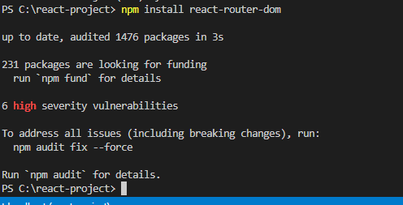

## We use **mdb-react-ui-kit** in our project. MDB is a collection of free Bootstrap templates, themes, design tools & resources. It is used to develop our website easier.

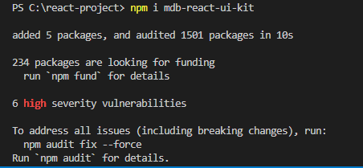

Next we create a **components** folder inside of **src**. Inside of components folder we created the following **jsx** files.

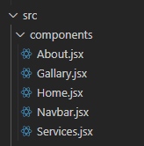

We can see that extension of every files are jsx.

JavaScript XML

JSX stands for **JavaScript XML**. JSX allows us to write HTML in React. JSX makes it easier to write and add HTML in React.

**App.js**

 import About from './components/About';

import Gallery from './components/Gallary';

import Home from './components/Home';

import Service from './components/Services';

import Navbar from './components/Navbar';

import { Route,Routes } from 'react-router-dom';

import 'mdb-react-ui-kit/dist/css/mdb.min.css';

function App() {

  return (

    <>

    <Navbar/>

    <div className='container'>

    {/* {component} */}

    <Routes>

      <Route path="/" element={<Home/>}></Route>

      <Route path="/about" element={<About/>}></Route>

      <Route path='/service' element={<Service/>}></Route>

      <Route path="/gallery" element={<Gallery/>}></Route>

    </Routes>

    </div>

    </>

  );

}

export default App;

App. js is built **to serve makers of static single-page apps**. This means that it keeps all page navigation within the session of the webpage, defining "pages" as DOM nodes that can be instantiated. Pages are HTML elements that have certain generic components like a topbar and content area.

Here we can see the <Navbar/>. It will place the Navbar.jsx.

      <Route path="/" element={<Home/>}></Route>

The above line says that our default root is home.

**Navbar.jsx**

import Container from 'react-bootstrap/Container';

import Nav from 'react-bootstrap/Nav';

import Navbar from 'react-bootstrap/Navbar';

function Navbar1() {

  return (

    <Navbar bg="primary" expand="lg" >

      <Container>

        <Navbar.Brand href="/" style={{color:"white"}}>TKA</Navbar.Brand>

        <Navbar.Toggle aria-controls="basic-navbar-nav" />

        <Navbar.Collapse id="basic-navbar-nav">

          <Nav className="me-auto">

          </Nav>

          <Nav>

            <Nav.Link href="/" style={{color:"white"}}>Home</Nav.Link>

            <Nav.Link href="/about" style={{color:"white"}}>About Us</Nav.Link>

            <Nav.Link href="/gallery" style={{color:"white"}}>Gallery</Nav.Link>

            <Nav.Link href="/service" style={{color:"white"}}>Services</Nav.Link>

          </Nav>

        </Navbar.Collapse>

      </Container>

    </Navbar>

  );

}

export default Navbar1;

**Home.jsx**

import Carousel from 'react-bootstrap/Carousel';

import React from "react";

import "../css/styles.css"

function Home() {

    return (

      <div>

      <Carousel>

        <Carousel.Item >

          <img

            className="d-block w-100"

            src="/images/project-managemenr-goals.jpg"

            alt="First slide"

            width="100%"

            height="600px"

          />

          <Carousel.Caption>

            <h3 >Transforming organisations and individuals across the world.</h3>

            <p></p>

          </Carousel.Caption>

        </Carousel.Item>

        <Carousel.Item>

          <img

           className="d-block w-100"

           src="/images/img1.png"

           alt="Second slide"

           width="100%"

           height="600px"

          />

          <Carousel.Caption>

            <h3 >Largest global course portfolio</h3>

          </Carousel.Caption>

        </Carousel.Item>

        <Carousel.Item>

          <img

             className="d-block w-100"

             src="/images/itil.jpg"

             alt="Third slide"

             width="100%"

             height="600px"

          />

          <Carousel.Caption>

            <h3>Multichannel delivery</h3>

          </Carousel.Caption>

        </Carousel.Item>

      </Carousel>

      <h4 style={{color:"#5b2bd2"}}>Largest global course portfolio</h4>

      <p style={{color:"orange"}}>   You won’t find better value in the marketplace. If you do find a lower price, we will beat it. </p>

      <h4 style={{color:"#5b2bd2"}}>Most venues globally</h4>

      <p style={{color:"orange"}}>  We have locations stretching the entire globe, allowing flexible training wherever you need it. </p>

      <h4 style={{color:"#5b2bd2"}}>Best choice of dates for classroom courses</h4>

      <p style={{color:"orange"}}>   A variety of delivery methods are available depending on your learning preference. </p>

      </div>

    );

  }

export default Home;

**About.jsx**

import React from 'react';

import {

  MDBCard,

  MDBCardBody,

  MDBCardTitle,

  MDBCardText,

  MDBBtn

} from 'mdb-react-ui-kit';

export default function About() {

  return (

    <MDBCard>

      <MDBCardBody>

        <MDBCardTitle style={{color:"#5b2bd2"}}>Welcome to The Knowledge Academy</MDBCardTitle>

        <img

            className="d-block w-100"

            src="/images/img3.png"

            alt="First slide"

            width="100%"

          />

           <MDBCardText style={{color:"orange"}}>

           Over the course of the current health crisis we’ve adapted the way we work to allow our clients to continue getting the same great quality training, whilst in a safe environment. All of our courses are available as online instructor-led, you get the feel of a classroom course but from the comfort of your own home.

        </MDBCardText>

        <MDBCardText style={{color:"pink"}}>

        An awarded & globally established provider of training courses

        </MDBCardText>

        <MDBCardText>

        globally, with extensive experience of providing quality-infused learning solutions -

        </MDBCardText>

        <MDBCardText>

        with the capability to deliver over 30,000 courses, in 1000+ locations, across 190

        </MDBCardText>

        <MDBCardText>

        countries. As market leaders, we have successfully trained over 1 million delegates

        </MDBCardText>

        <MDBCardText>

        - demonstrating our internationally-renowned trust and unrivalled premiums

        </MDBCardText>

        <MDBBtn href='https://www.theknowledgeacademy.com/' style={{backgroundColor:"orange"}}>Read more</MDBBtn>

      </MDBCardBody>

    </MDBCard>

  );

}

**Gallery.jsx**

import '../css/styles.css';

import {

  MDBCard,

  MDBCardImage,

  MDBRow,

  MDBCol

} from 'mdb-react-ui-kit';

function Gallary() {

  return (

    <MDBRow className='row-cols-1 row-cols-md-2 g-4'>

    <MDBCol>

      <MDBCard>

        <MDBCardImage

          src='/images/crm_training.jpg'

          alt='...'

          position='top'

        />

      </MDBCard>

    </MDBCol>

    <MDBCol>

      <MDBCard>

        <MDBCardImage

          src='/images/project-managemenr-goals.jpg'

          alt='...'

          position='top'

        />

      </MDBCard>

    </MDBCol>

    <MDBCol>

      <MDBCard>

        <MDBCardImage

          src='/images/img2.jpg'

          alt='...'

          position='top'

        />

      </MDBCard>

    </MDBCol>

    <MDBCol>

      <MDBCard>

        <MDBCardImage

          src='/images/img1.png'

          alt='...'

          position='top'

        />

      </MDBCard>

    </MDBCol>

  </MDBRow>

  );

}

export default Gallary;

**Service.jsx**

import Card from 'react-bootstrap/Card';

import CardGroup from 'react-bootstrap/CardGroup';

import '../css/styles.css';

import Accordion from 'react-bootstrap/Accordion';

function Service() {

  return (

    <div>

    <CardGroup  className='list'>

      <Card>

        <Card.Img variant="top" src="/images/prince2.png" />

        <Card.Body>

          <Card.Title>PRINCE2@</Card.Title>

          <Card.Text>

          PRINCE2® is a credible and prominent methodology that concentrates on boosting productivity and extracting the best from resources

          </Card.Text>

        </Card.Body>

        <Card.Footer>

          <small className="text-muted">Last updated 3 mins ago</small>

        </Card.Footer>

      </Card>

      <Card>

        <Card.Img variant="top" src="/images/img10.png" />

        <Card.Body>

          <Card.Title>ITIL®</Card.Title>

          <Card.Text>

          This ITIL 4 Foundation course is designed to give delegates a comprehensive understanding of the ITIL framework and its role in modern ITSM. This ITIL course covers the following

          </Card.Text>

        </Card.Body>

        <Card.Footer>

          <small className="text-muted">Last updated 3 mins ago</small>

        </Card.Footer>

      </Card>

      <Card>

        <Card.Body>

          <Card.Title style={{color:"#5b2bd2"}}>Lean Six Sigma</Card.Title>

          <Card.Text>

          Lean Six Sigma (LSS) is a methodology used to improve business processes, based on the combination of two management ideologies, Lean and Six Sigma.

          </Card.Text>

        </Card.Body>

        <Card.Footer>

          <small className="text-muted">Last updated 3 mins ago</small>

        </Card.Footer>

      </Card>

    </CardGroup>

    <Accordion defaultActiveKey="0">

      <Accordion.Item eventKey="0">

        <Accordion.Header style={{color:"#5b2bd2"}}>Maximum budget efficiency</Accordion.Header>

        <Accordion.Body style={{color:"#5b2bd2"}}>

        Our training pass services allow you to take full control of your budget and get the most for your money.

        </Accordion.Body>

      </Accordion.Item>

      <Accordion.Item eventKey="1">

        <Accordion.Header style={{color:"#5b2bd2"}}>Dedicated account manager</Accordion.Header>

        <Accordion.Body style={{color:"#5b2bd2"}}>

        Your on hand account manager is committed to delivering the best possible service.

        </Accordion.Body>

      </Accordion.Item>

    </Accordion>

    </div>

  );

}

export default Service;

After writing the above code. We can run our project using **npm start.**

**Our final output will be look like as following**

**Home page**

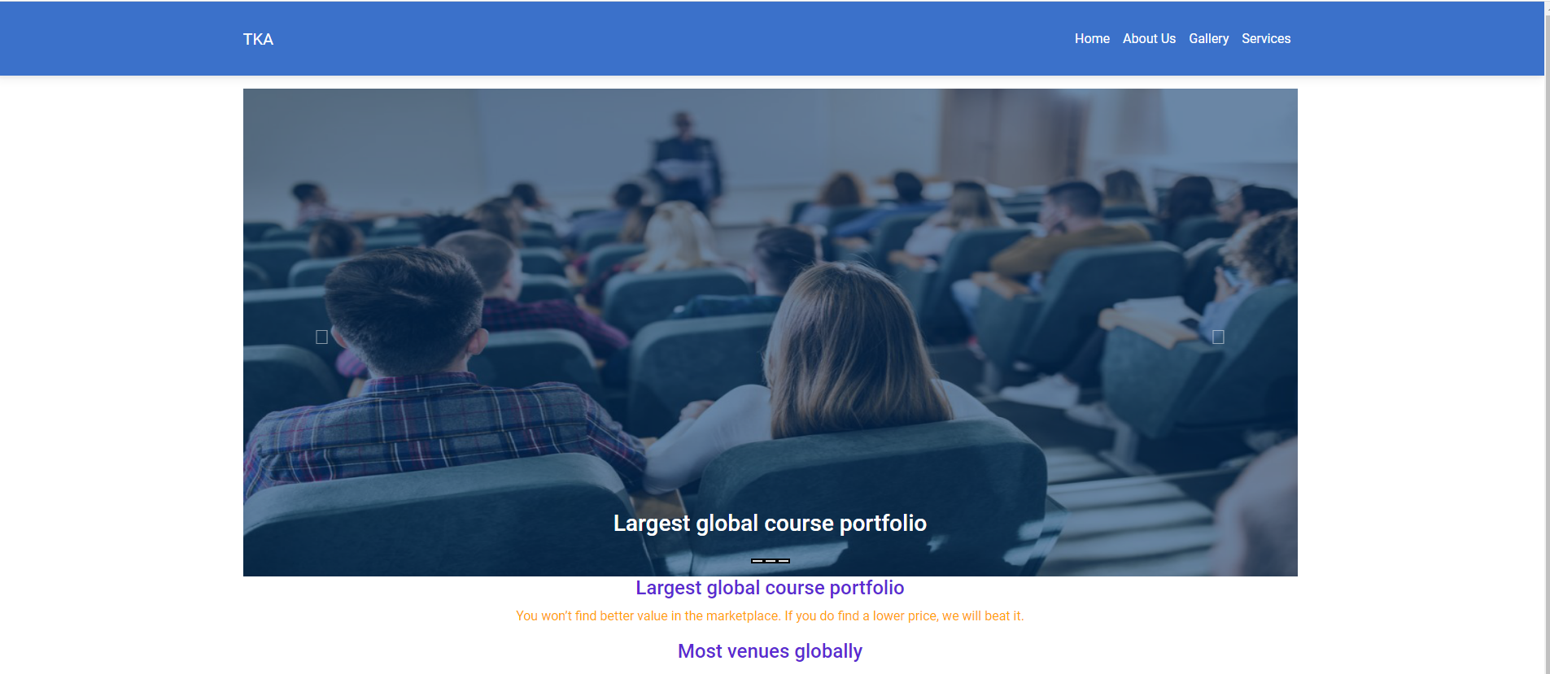

**About us**

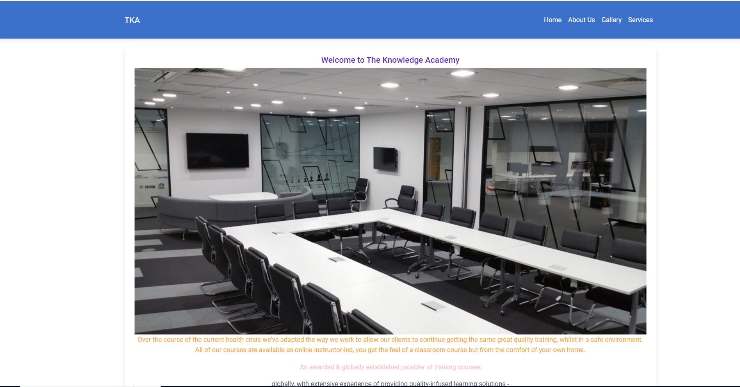

**Gallery**

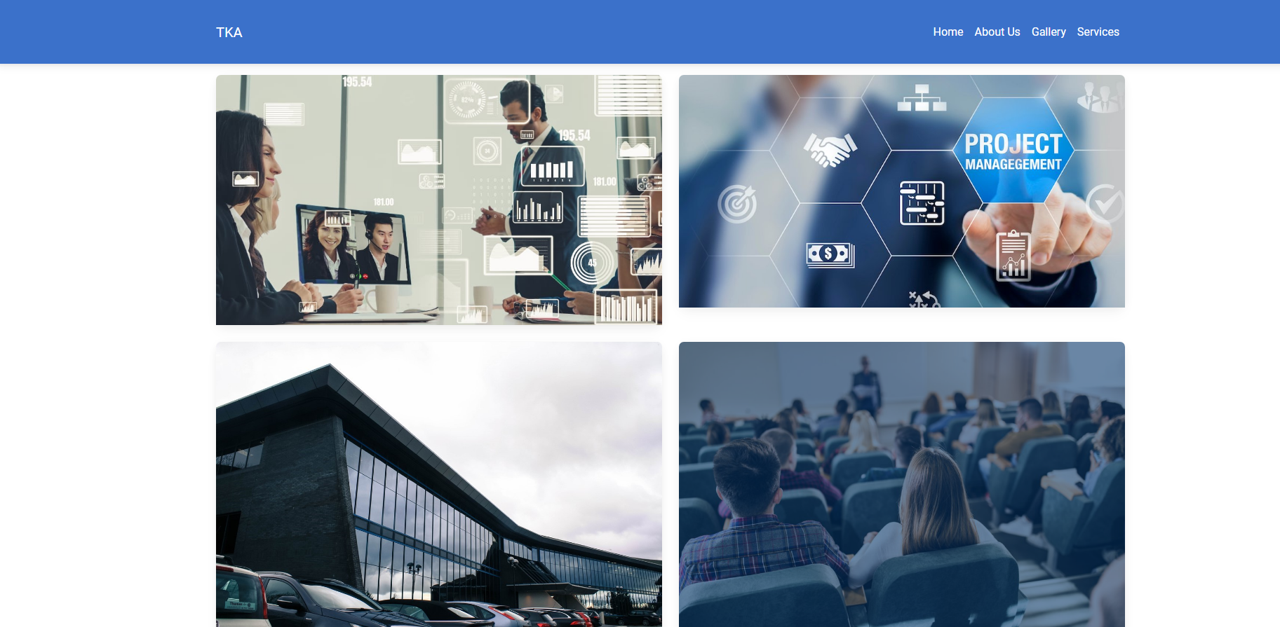

**Service page**

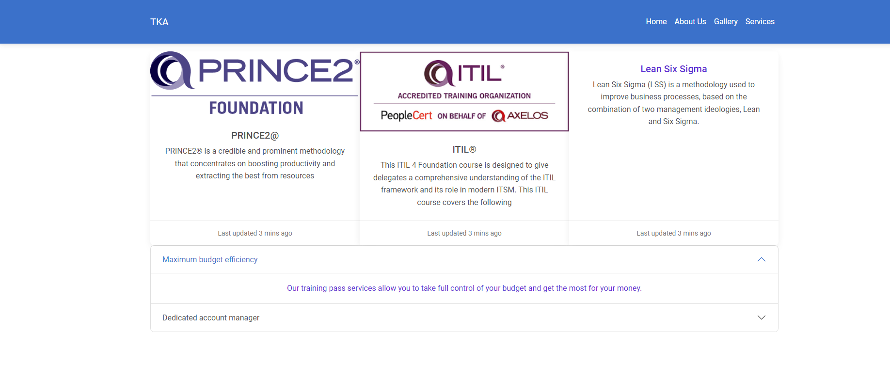

The GitHub link is <https://github.com/knowledgeacademy532/react-project>

v